**BHASWANTH AYAPILLA**

**2020AAPS0304H**

1 (a)

Green line - right wheel

Red line - left wheel

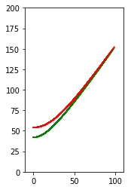

1 (b)

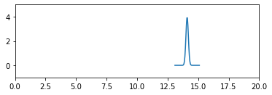

1 (c)

